**Project Report Template**

1.Introduction:

* 1. **Overview**

This is the process that facilitates easy procurement of desired merchandise from **retail stores** for the sole purpose of personal consumption. It is an elaborate.

* 1. **Purpose**

Retail management optimizes internal processes such as inventory management, offline and online storefronts, warehouse operations, payment and accounting, and human resources. Retail management improves overall company cohesion. Retail store management improves customer experience and boosts customer satisfaction..

2.Problem Definition & Design Thinking:

2.**1 Empathy Map**

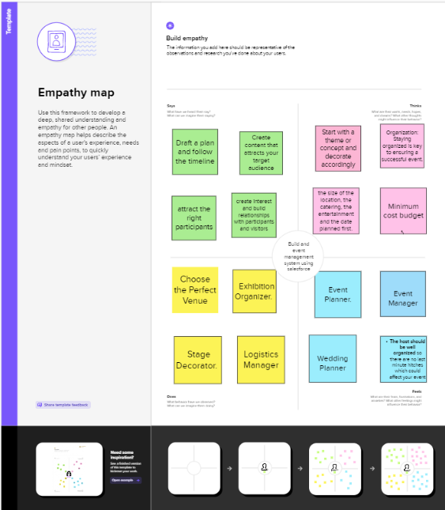

**2.2 Ideation & Brainstorming Map**

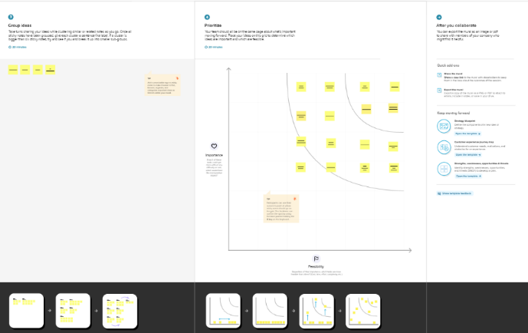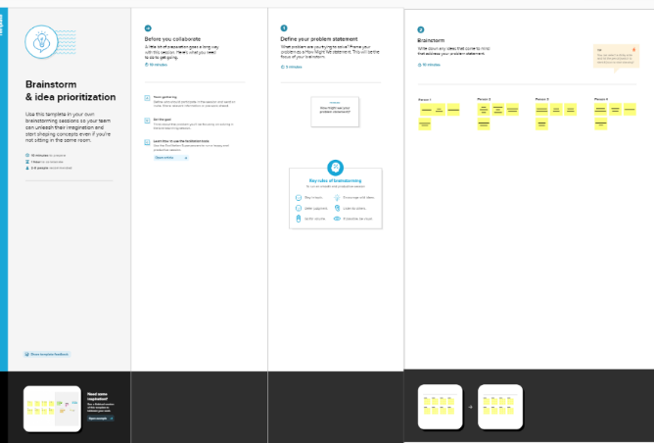

3.RESULT:

**3.1 Data Model*:***

|  |  |
| --- | --- |
| Object name | Fields in the Object |
| Standard objects | |  |  | | --- | --- | | Field Label | Data Type | | Display/tracking | Text | | Tracking ID | Text | |
| Custom object | |  |  | | --- | --- | | Field Label | Data Type | | Dispatched | Text | | Tracking ID | Text | |

**3.2 Activity & Screenshort**

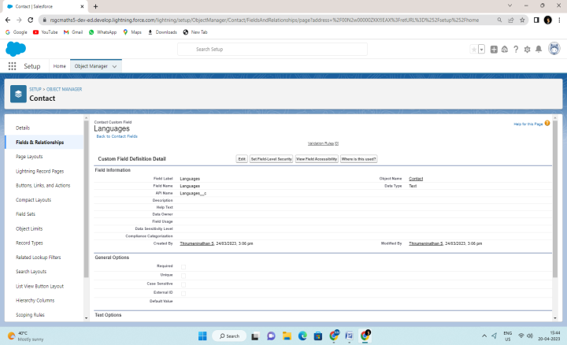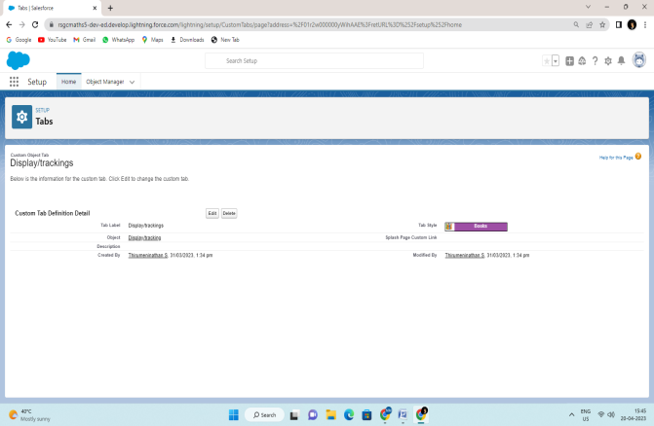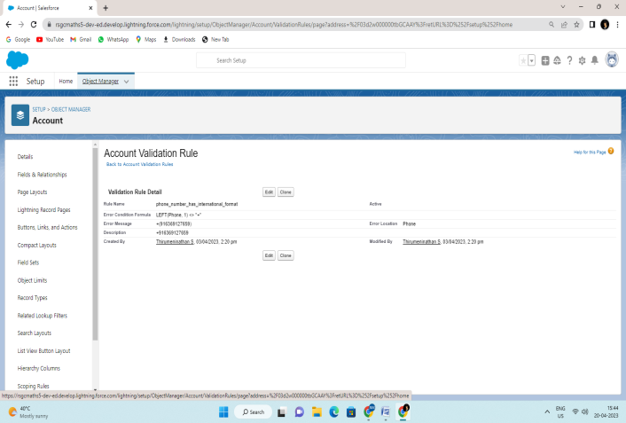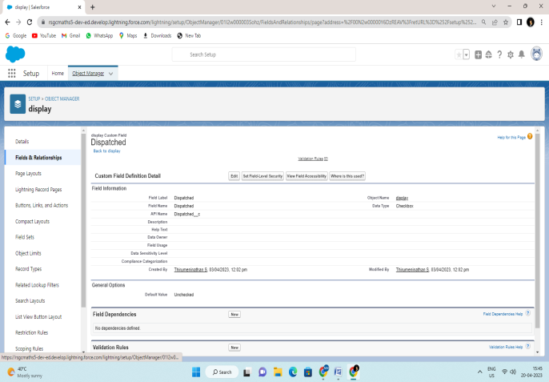

4 . Trailhead Profile URL:

Team Leader- https://trailblazer.me/id/nathans

Team Member-https://trailblazer.me/id/akashrcb

Team Member-https://trailblazer.me/id/chandrum

Team Member-https://trailblazer.me/id/sasaravanan

5. ADVANTAGES:

* Customer satisfaction. The biggest advantage of retail management is customer satisfaction. ...
* Hassle-free shopping. ...
* Prevents unnecessary chaos and shoplifting activities. ...
* Proper accounting. ...

DISADVANTAGES:

* Inadequate capital is always a big problem to their trade.
* No room for expansion due to lack of enough capital.
* Inability to enjoy economies of scale.
* Do not easily obtain loan

**6.**  APPLICATIONS:

* Retail management optimizes internal processes such as inventory management,
* offline and online storefronts, warehouse operations, payment and accounting, and human resources.
* Retail management improves overall company cohesion.
* Retail store management improves customer experience and boosts customer satisfaction.

**7.**  CONCLUSION:

* You have been introduced to some of the key areas of marketing communications – the message, the media and the communication tools.
* You have considered the basics of the communication model that underpins the development of marketing communication messages.
* You have also explored what it takes to develop a communication message, how to use communications to build a brand and the characteristics of the different media that might carry marketing communications.
* In addition, you have identified a range of communication tools which make up the marketing communication mix

8. FUTURE SCOPE:

* administrative services are all options for candidates with a retail management background.
* More than 2 million jobs are available in retail management around the world.
* Retailing has a very wide scope. It is one of the fastest growing industries in India and is providing employment opportunities to many people